# CS 255 System Design Document Template

This template lays out all the different sections that you need to complete for Project Two. Each section has guidance to prompt your thinking. You will need to continually reference the interview transcript as you work to make sure that you are addressing your client’s needs. There is no required length for the final document. Instead the goal is to complete each section based on what your client’s needs are. Remove this note when you are finished, and replace all bracketed text with the relevant information.

## UML Diagrams

### UML Use Case Diagram

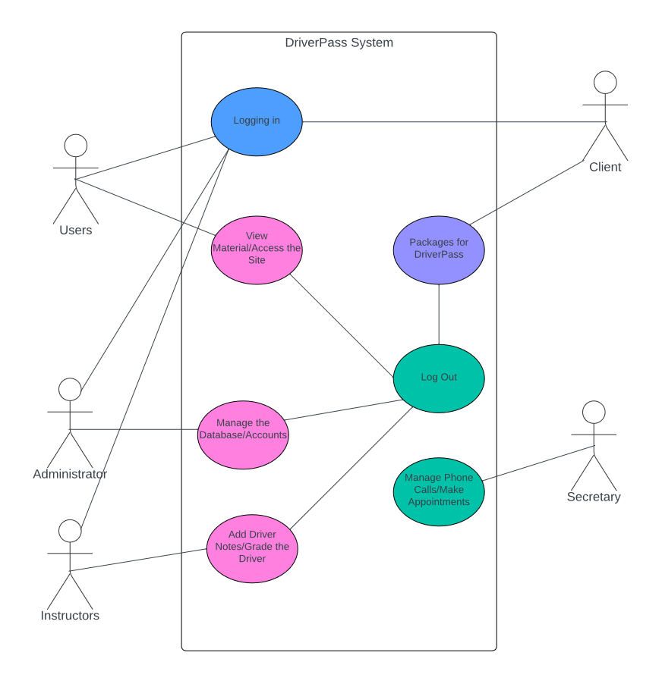

### UML Activity Diagrams

User Login Diagram

Scheduling Appointments

### UML Sequence Diagram

Payment and scheduling appointments

### UML Class Diagram

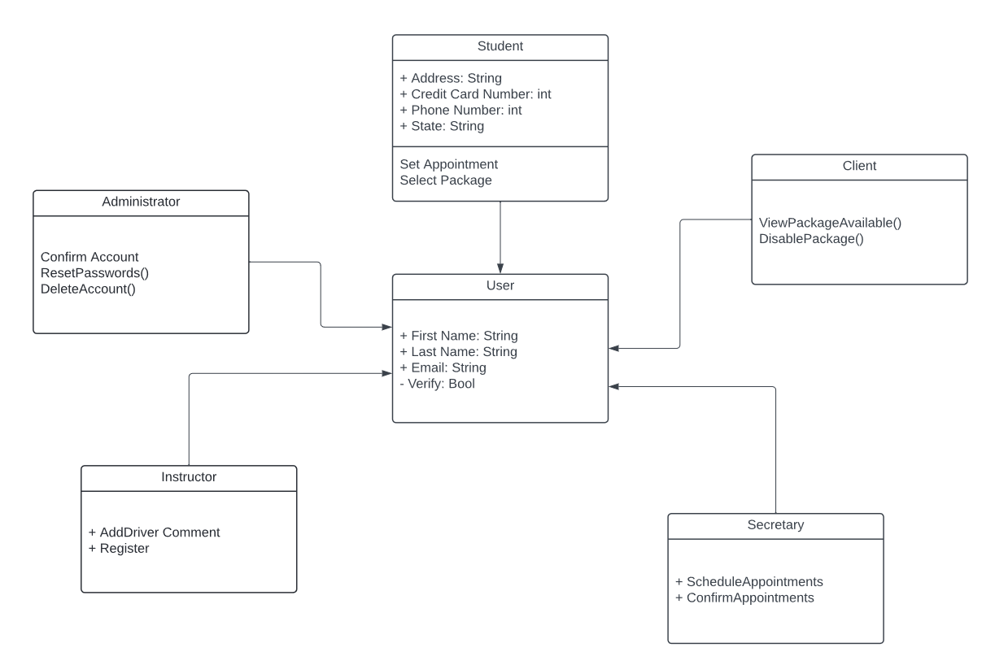

## Technical Requirements

Based on the diagrams I created the technical requirements of this system are that the system needs to be able to validate payments, validate user requests, allow the user to access content, have the ability to disable packages, schedule appointments, and the ability to have password resets.